Sunday, November 20th, 2022

Checklist:

* Product backlog
  + ~~Users stories~~
  + ~~Assign effort value. Playing poker?~~
  + Features table (started, wait for backend)
  + ~~Diagrams (logic done)~~
* Sprint backlog
  + ~~Users stories~~
  + ~~Assign effort value. Playing poker?~~
  + Features table (started, wait for backend)

Notes:

Sample of Planning poker for story points. Values based on Fibonacci sequence.

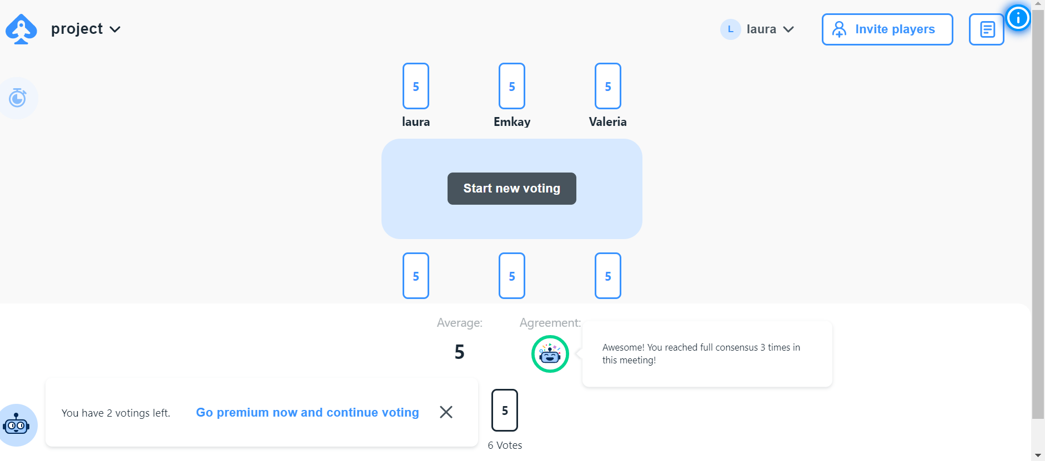

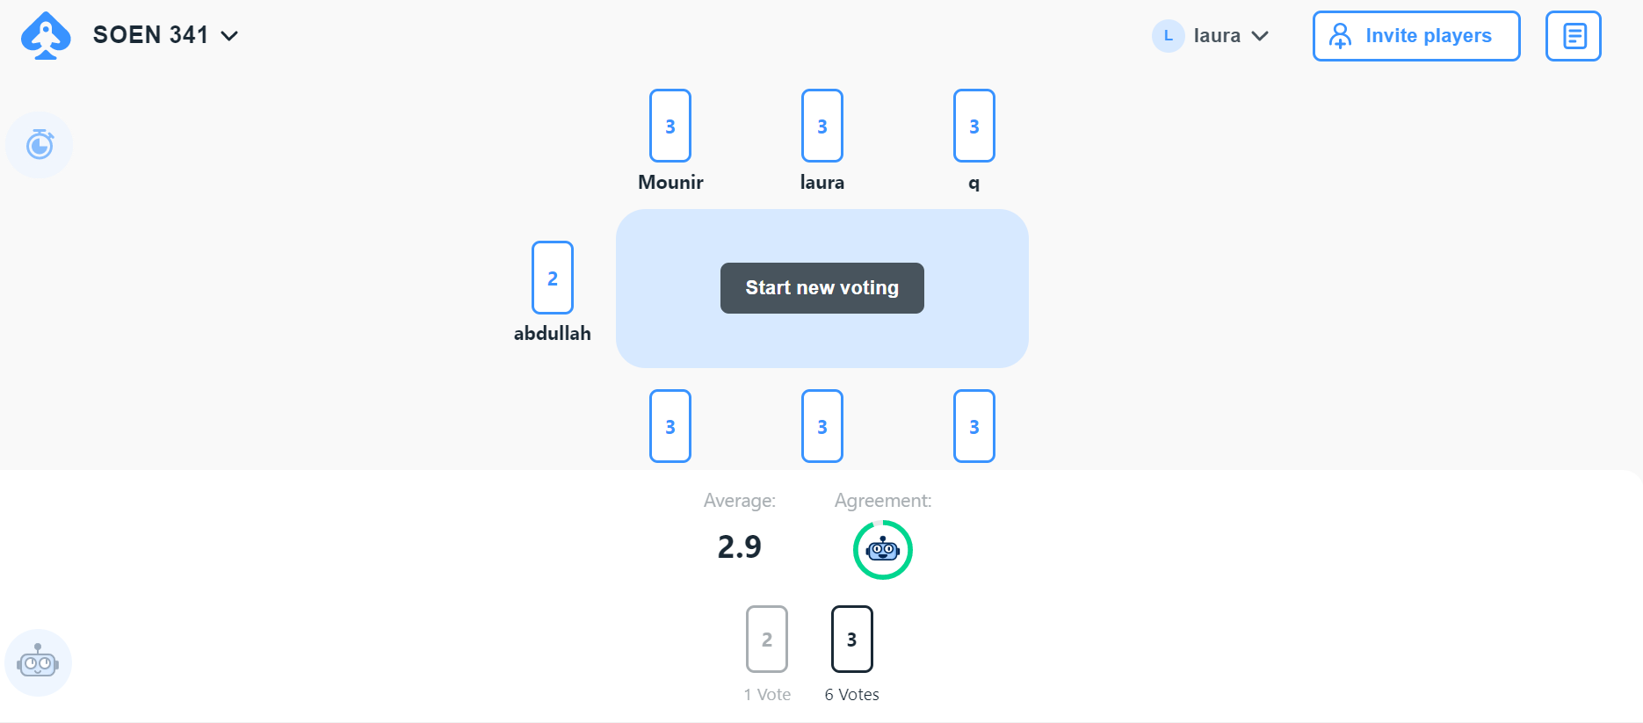

Order history

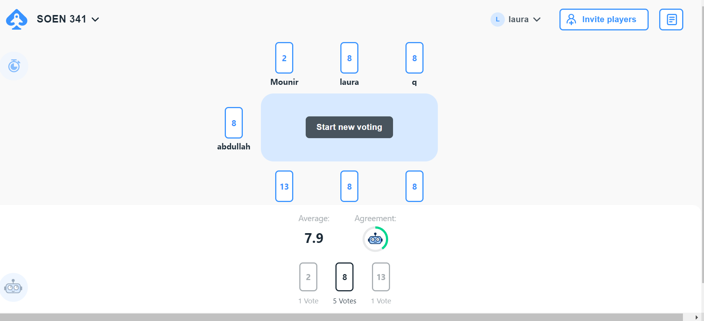

Add items/del

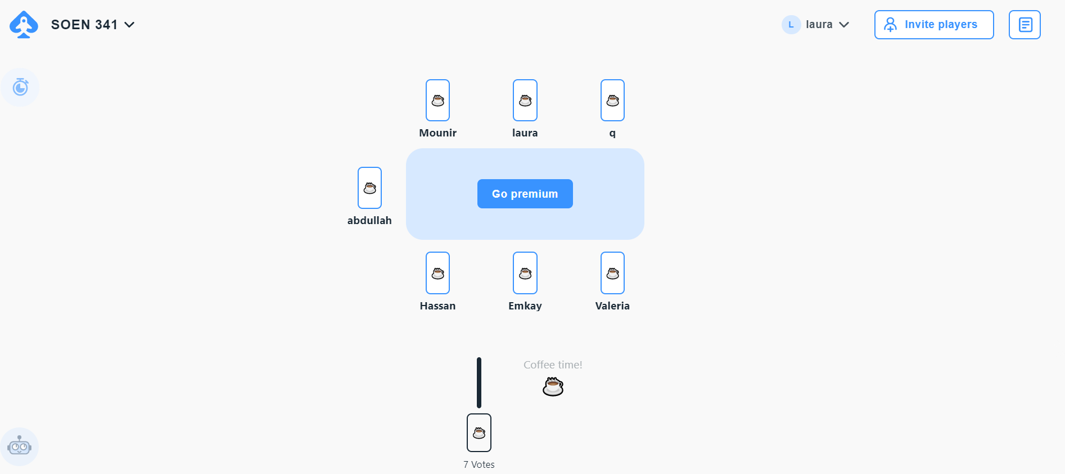

Coffee break

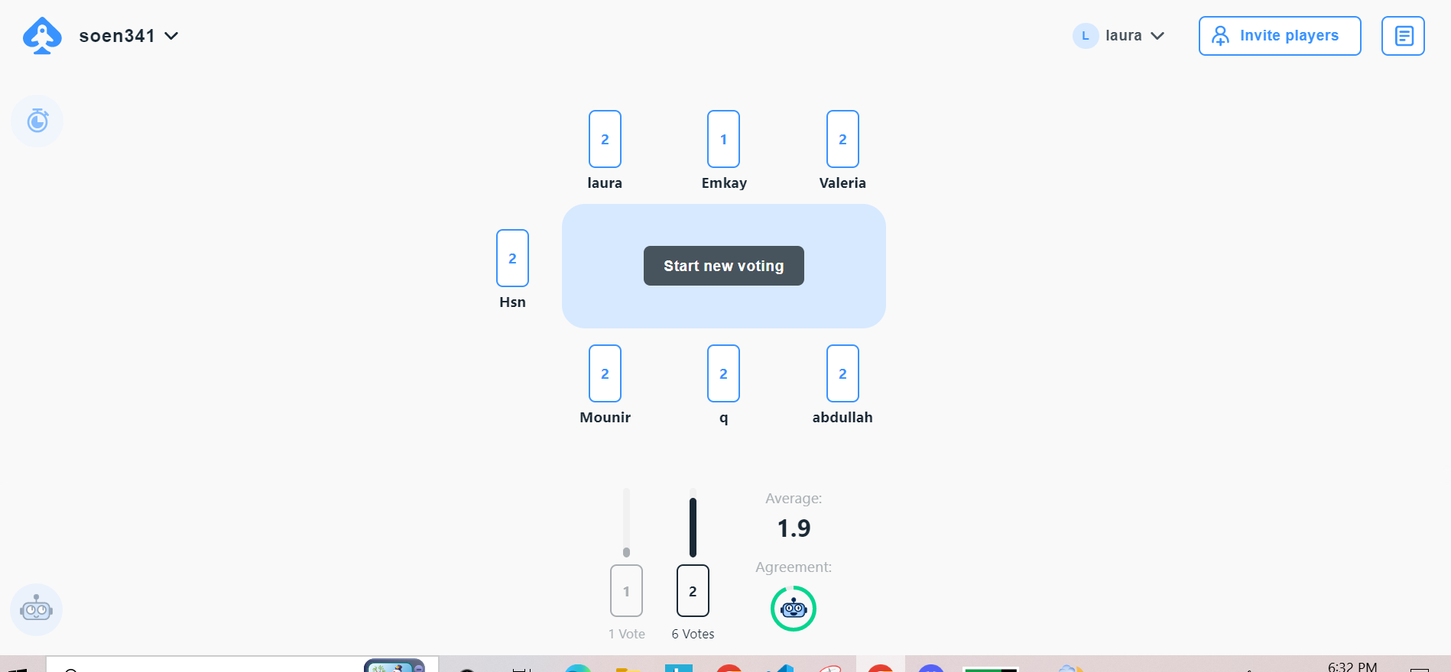

Confirm order